**GITHUB Account**

<https://enterprise.github.com/home>

At first for we have to choose a trial version of 45 days and later can be upgraded to full licenses at any time during the trial period.

## Pricing = $2,500 per 10 users / year [full licensed version]

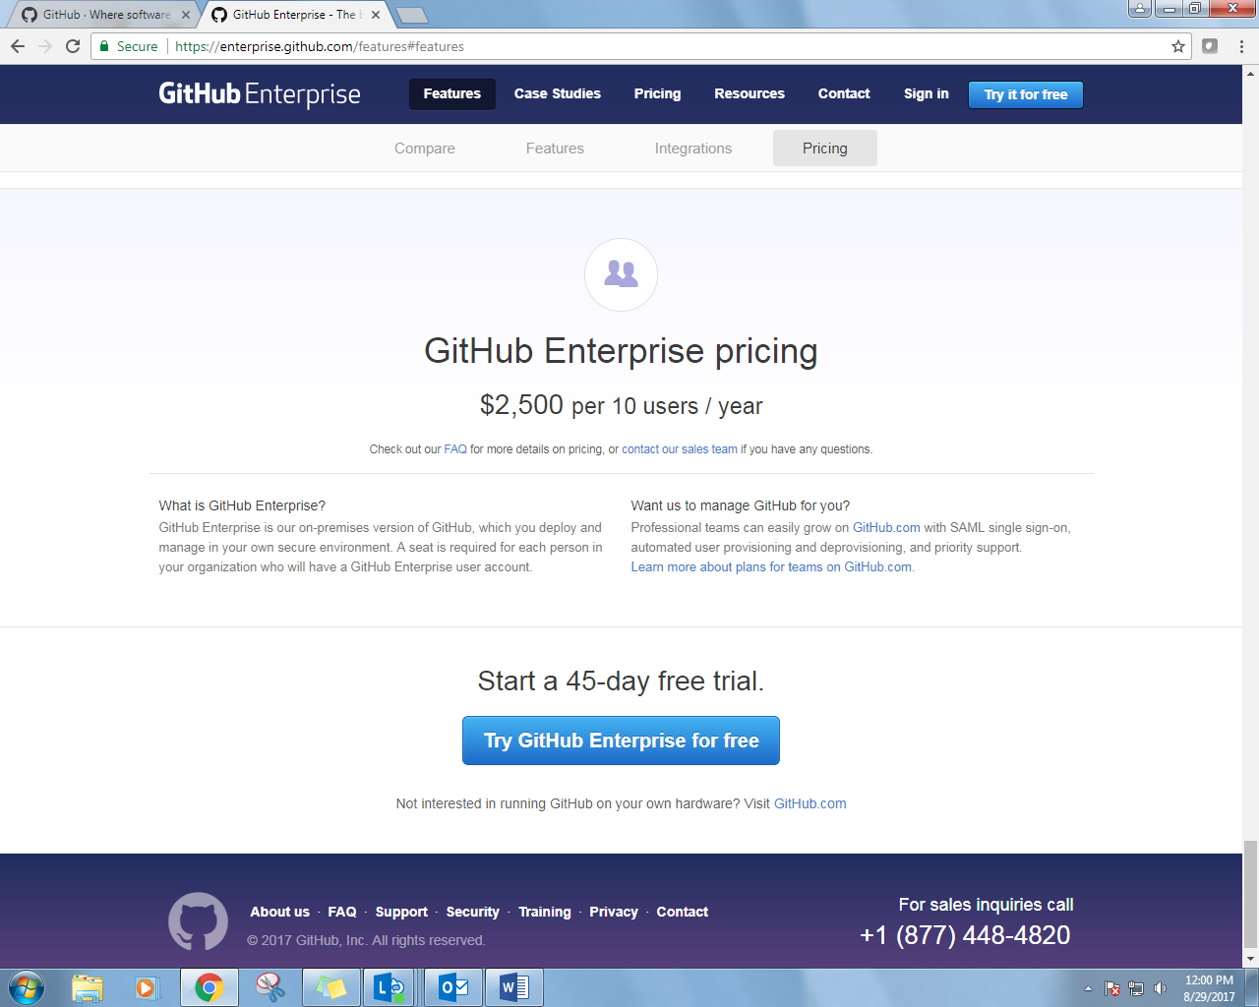

The following installation types are available while regestring for free version

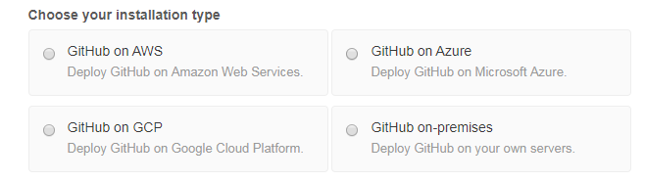

Hardware Requirements

* **Processor:** Two 3.0 GHz CPU cores *(or virtual equivalent)*
* **Memory:** 14-16 GB (minimum dependent on selected platform)
* **Disk:**
  + 80 GB VM root partition
  + 100 GB data partition (our recommendation, actual size depends on your data)
* **Storage:** High-performance SAN or locally attached storage

Supported VM Environments for full licensed version

